Workshop on
Effects of Climate Change on the Indian Ocean Marine Environment
20-22 February 2023
Tehran, Islamic Republic of Iran
9:30-16:30 (Iran Standard Time – GMT +3:30)

Speakers
FOREIGN SPEAKERS

 | Name of Speaker | Affiliation | Country | Email | Title of Presentation
 | Dr. S.W.A. Naqvi, FNASc, FASc, FNA, FTWAS, | Geochemistry Fellow,  Former Director, National Institute of Oceanography, Goa  Now Distinguished Visiting Professor  Department of Earth Sciences  Indian Institute of Technology  Kanpur 208016, India  Mob: +91 96433 14093 | INDIA | naqvi@nio.org | Deoxygenation in the Northwestern Indian Ocean  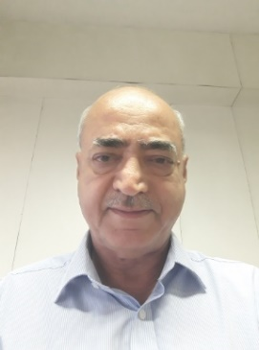
 | Dr. Roxy Mathew Koll | Scientist, Centre for Climate Change Research, Indian Institute of Tropical Meteorology, Ministry of Earth Sciences, India | INDIA | roxy@tropmet.res.in | "Climate change in the Indian Ocean and the need for improved observations and predictions."  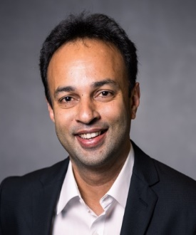
 | Dr. Abhisek Chatterjee | Scientist 'E'  Indian National Centre for Ocean Information Services (INCOIS),  Ministry of Earth Sciences, Government of India,  Hyderabad-500090  Phone no. (office) +91-4023886030 (Office Hours: 9 am-5:30 pm IST)  (mobile) +91-8332050495  Fax: +91-40-23892910 | INDIA | abhisek.c@incois.gov.in | "Impact of climate change on the marine heatwaves of the Indian Ocean"  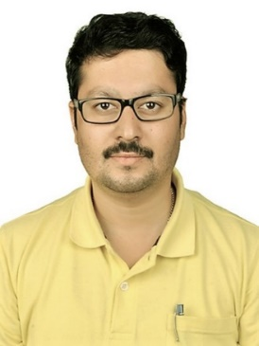
 | Dr. Sanjiba Kumar Baliarsingh | Scientist  Applied Research and Research to Operations (ARO) Division  Ocean Modeling, Applied Research & Services (OMARS) Group  Indian National Centre for Ocean Information Services (INCOIS)  [Ministry of Earth Sciences | Govt. of India] ,Hyderabad-500090| Telangana India | INDIA | baliarsingh.s@incois.gov.in | Marine Primary Production in the North Indian Ocean: Implication of Climate Change  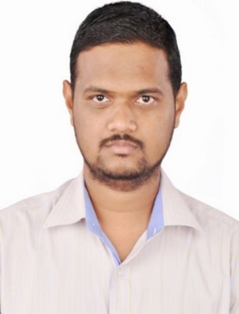
 | Dr. R S Mahendra | Scientist E, Applied Research and Research to Operations (ARO) Division, Operational Ocean Services & Applied Research (OSAR) Group, Indian National Centre for Ocean Information Services (INCOIS), Ministry of Earth Sciences (MoES),  "Ocean Valley",Pragathi Nagar (BO), Nizampet (SO)n Hyderabad-500090 | INDIA | mahendra@incois.gov.in | Mapping and monitoring of Coral and Mangrove ecosystems of India using geospatial techniques  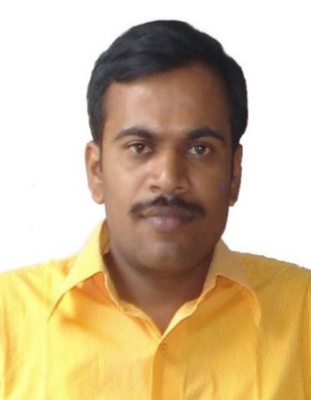
 | Professor P.B. Terney Pradeep Kumara | Department of Oceanography  Faculty of Fisheries and Marine Sciences and Technology  University of Ruhuna, Matara, Sri Lanka | Sri Lanka | terneypradeep@yahoo.co.uk | 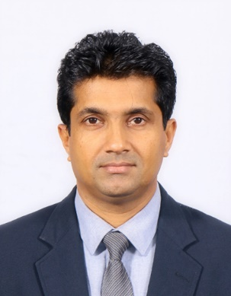
Iranian Speakers

 | Dr. Mohammad Reza Shokri | Associate Professor  Department of Animal Sciences and Marine Biology  Faculty of Life Sciences and Biotechnology  Shahid Beheshti University  Zip Code:1983969411  Evin, Tehran, I.R. Iran  Office phone: +98-21-2990 5925  Office fax: +98-21-2243 1664  Cell: 0912 409 7464 | Iran | M_Shokri@sbu.ac.ir | The fate of coral reefs of the marginal sea "the Persian Gulf" under the changing climate
 | Dr. Mohammad Ali Hamzeh, | Scientific Member, INIOAS | Iran | Hamzeh@inio.ac.ir | Impact of Holocene Indian summer monsoon oscillations on South East Iranian Plateau  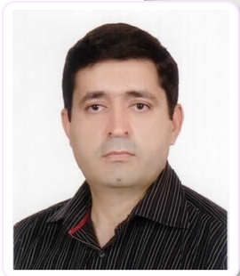
 | Dr. Hamid Ershadifar, | Scientific Member, INIOAS | Iran | hamid.ershadifar@inio.ac.ir | Nutrient biochemistry in marginal seas of northwestern Indian Ocean under climate change
 | Dr. Abdolmajid Naderi Beni | Scientific Member, INIOAS | Iran | majid.naderi@gmail.com | 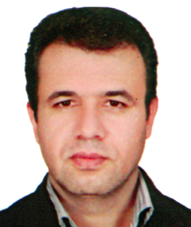
 | Dr Parvin Ghaffarian | Scientific Member, INIOAS | Iran | p.ghafarian@inio.ac.ir | The long-term variability of meteorological parameters over the Indian Ocean  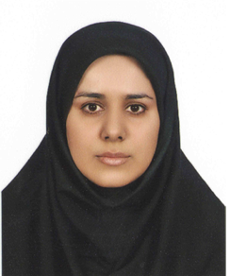
 | Dr. Nafiseh Pegahfar | Scientific Member, INIOAS | Iran | pegahfar@inio.ac.ir | Relationship between climatic indices and TC characteristics over the Indian Ocean
 | Dr Fereidoun Oufi | Academic member, Iranian Fisheries Science and Research Institute | Iran | sillaginid@hotmail.com | The effects of climate change on the alien and invasive marine species migration behavior, in the NW Indian Ocean seas
 | Dr. Omid Alizadeh Choobari | University of Tehran, Institute of Geophysics | Iran | omid.alizadeh@ut.ac.ir | El Nino flavors and their linkage to the Indian Ocean Dipole

