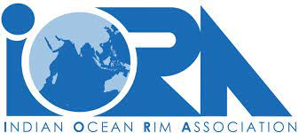

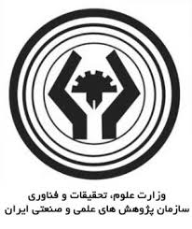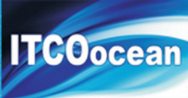**E:\My PICTURE\logo\RCOWA-UNESCO New-2022.eps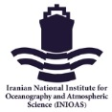**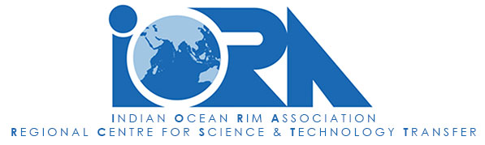

**IOC Regional Committee for the Central Indian Ocean (IOCINDIO)**

**The Third Phase of Workshop Series on**

**Effects of Climate Change on the Indian Ocean Marine Environment**

**20-22 February 2023**

**Tehran, Islamic Republic of Iran**

**09:00-16:30 (Iran Standard Time – GMT +3:30)**

Dear Delegate,

We look forward to welcoming you to the Third Phase of Workshop Series on Effects of Climate Change on the Indian Ocean Marine Environment which will be hosted in Tehran, I.R. Iran during 20-22 February 2023.

The workshop is being jointly organized by the IORA Regional Centre for Science & Technology Transfer (RCSTT) and the Iranian National Institute for Oceanography and Atmospheric Science (INIOAS) in collaboration with the IORA Secretariat and the Working Group on Blue Economy (WGBE).

**ORGANIZERS:**

IORA Regional Centre for Science & Technology Transfer (RCSTT)

The Iranian National Institute for Oceanography and Atmospheric Science (INIOAS)

Iranian Research Organization for Science and Technology (IROST)

Regional Education and Research Centre on Oceanography for West Asia (RCOWA) under the auspices of UNESCO

**IN COOPERATION WITH:**

Indian Ocean Rim Association (IORA) Secretariat

The Intergovernmental Oceanographic Commission of UNESCO (IOC-UNESCO)

IOC Regional Committee for the Central Indian Ocean (IOCINDIO)

**ORGANIZING COMMITTEE:**

**The Iranian National Institute for Oceanography and Atmospheric Science (INIOAS)**

Dr. Mortaza Tavakoli, INIOAS: inioas@inio.ac.ir

Dr. Ali Mehdinia, INIOAS: [mehdinia@inio.ac.ir](mailto:mehdinia@inio.ac.ir)

Ms. Fahimeh Foroughi, INIOAS: foroghi@inio.ac.ir

**RCSTT**

Dr. Sanjabi, RCSTT, Director: msanjabii@gmail.com

Ms. Fereshteh Moradi, RCSTT Chief Coordinator: [fereshteh.moradi@gmail.com](mailto:fereshteh.moradi@gmail.com)

**IORA Secretariat**

IORA Secretariat Headquarters: [hq@iora.int](mailto:hq@iora.int)

Dr Shamimtaz B. Sadally Roomaldawo, IORA Project Manager (Blue Economy): shamimtaz.sadally@iora.int

# PROGRAMME DURATION AND TIMING

# The third phase of the Workshop Series on Effects of Climate Change on the Indian Ocean Marine Environment will be held in person on 20-22 February 2023 in Tehran, Islamic Republic of Iran.

The workshop is planned to be held in three days including 7 sessions in two days and the third day is allocated to Closing Session and sight-seeing in Tehran.

**NOMINATION AND REGISTRATION**

Each IORA Member State is invited to nominate one representative to participate in the programme through National Focal Points, which is the Ministry of Foreign Affairs of their respective country. The Working Group on Blue Economy (WGBE) and the Working Group on Science, Technology and Innovation (WGSTI) are encouraged to participate in the workshop. Upon request to the organizing committee, a second participant may also be accepted under certain conditions.

All participants are required to fill the the “Registration Form” provided in Annex I, and provide a short profile/ bio-data (max. 200 words), with endorsement of the IORA National Focal Point. Completed registration forms should be sent to the following email addresses: info[.rcstt@gmail.com](mailto:.rcstt@gmail.com), [fereshteh.moradi@gmail.com](mailto:fereshteh.moradi@gmail.com), fahimeh.foroughi@gmail.com, with copy to the IORA Secretariat at [hq@iora.int](mailto:hq@iora.int) and [shamimtaz.sadally@iora.ing](mailto:shamimtaz.sadally@iora.ing) **by no later than February 4, 2023.**

**HOSPITALITY**

**Accommodation for Delegates from IORA Member States and the related Working Groups**

Full hospitality will be extended to only one delegate from each IORA Member State and the related Working Groups. Full hospitality covers one international return air ticket (most direct and economy class), hotel / guest house accommodation with breakfast / all the meals, transport to and from the airport, local transport to and from hotel/guest house to and from the workshop venue .

Upon request to the organizing committee, a second participant may also be accepted and will be provided with local hospitality only that is accommodation, meals and transport to and from the airport **(No international travel cost is provided).**

The applicants from “Dialogue Partners” (one from each Dialogue Partner) will also be provided with local hospitality that is accommodation, meals and transport to and from the airport **(No international travel cost is provided).**

**VISA PROCEDURE**

All Delegates must hold a valid passport with a validity of at least 6 (six) months from the intended date of entry into the I.R. Iran, upon which they may apply for a Conference Visa to enter Iran. The Organizing Committee will assist to facilitate visa issuance for all the delegates who require a visa to enter Iran.

Formal invitation letters will be sent to the Delegate/s following their nomination by their respective IORA National Focal Points.

Any inquiry regarding visa regulations can be directed to the Iranian Embassy/ Consulate in the respective IORA Member States, with reference to the invitation for the Workshop.

**COVID-RELATED REQUIREMENTS TO IRAN**

All passengers over the age of 12 travelling to Iran should be fully vaccinated, with more than 14 days after the second dose of a two shot vaccine (or the single dose of the Johnson & Johnson/Janssen vaccine). Alternatively, passengers may provide a negative PCR test taken within 72 hours prior to arrival.

Passengers may undergo health screening upon arrival and may have to quarantine at government facilities if symptoms present.

All passengers arriving into Iran need to wear a mask on the plane and in the airport at all times.

**ATTIRE AND LANGUAGE:**

Business attire is recommended (although not a must) for the opening and closing sessions.

English will be the working language during the Workshop.

**ADDITIONAL INFORMATION**

**Iran Standard Time**

Time zone in Iran (GMT+3:30)

**Business Hours**

Public offices including banks and exchange centres are generally open from 8 am to 16 pm from

Saturday to Wednesday. However, the recreation areas and shopping centres are open between 10 am

to 23 pm all week days.

**Currency**

Rials, Tomans (each 10 Rials)

VISA card, Master card and other credit cards are not accepted in Iran.

It is better to bring your money (Euros /Dollars) in cash that you can change so easily in Tehran.

**Electricity**

In Iran the standard voltage is 220 V and the frequency is 50 Hz. You can use your electric appliances

in Iran, if the standard voltage in your country is in between 220 - 240 V (as is in the UK, Europe,

Australia and most of Asia and Africa).

**Tehran Weather in February**

The last month of the winter in Iran, [February](https://www.weather-atlas.com/en/iran/tehran-weather-february), is a very cold month with an average temperature varying between -1°C (30.2°F) and 7.4°C (45.3°F).